‘GEHIRNWAGEN

German road sign Identification

## presented by

Cody Overholt

Kyle Mueller

Jordan Carlson

I. Data Preprocessing & Model Training

During the training of the model, The data was preprocessed by rotating images and scaling the size of images to account for situations on the road where visibility of signs may be affected by the distance between the car and the sign as well as any irregularities between signs such as broken signs or ones that are tipped over. Our model was trained using CUDA acceleration and an NVIDIA GeForce RTX 3080 GPU.

II. Architecture

Inception V3 architecture was chosen due to its intricate depth, design, and reputation for effective CNN’s. The model was wrapped with our preprocessing layers and tuned to fit the 43 different classes of signs found in the data.

II. Model Summary

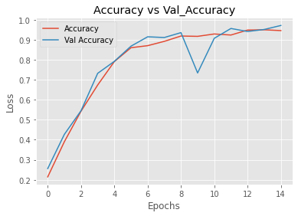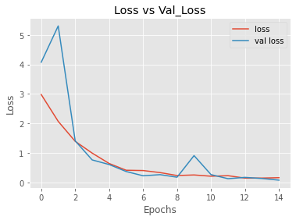

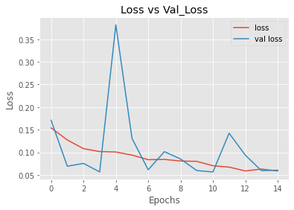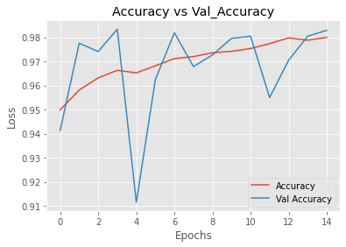

III. Conclusion

Without overfitting, our model was able to determine the classification of each sign with an accuracy of 98.29% and an average prediction score of 93.19%. We highly recommend using this model in your self driving cars. For implementation support please contact us. We also suggest improving your computer hardware to increase the speed it takes to train these networks in case any future training/maintenance is necessary. Thank you for consulting with us.

IV. Python Notebooks

Below are Github Gist links to the notebooks we used during this case study:

Jordan: <https://gist.github.com/JordanCarlson7/3dcc4690e558841de4e00730a40edc51>

Kyle: <https://gist.github.com/mueller14003/e84f83a1bc5daad20c66019f0a60f5cb>

Cody: <https://gist.github.com/codeholt/91946f7d3802df66a9706bc9f3d74020>